Honorable James E. Baker

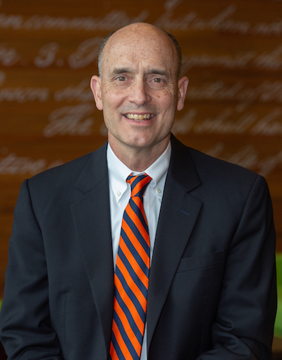

James E. Baker is Director of the Syracuse University Institute for Security Policy and Law, a Professor at the Syracuse College of Law and the Maxwell School of Citizenship and Public Affairs, and a Distinguished Fellow at the Georgetown Center for Security and Emerging Technology, Georgetown University. He previously served as a Judge and Chief Judge on the U.S. Court of Appeals for the Armed Forces. The USCAAF is a federal civilian court that hears cases arising in the military justice system. Appeal from the court is to the Supreme Court of the United States. Baker also served as a presidential appointed (Obama) member and Acting Chair of the Public Interest Declassification Board.
As a career civil servant, he served as Legal Adviser and Deputy Legal Adviser to the National Security Council. Baker has also served as Counsel to the President’s Foreign Intelligence Advisory Board and Intelligence Oversight Board, an attorney in the U.S. Department of State, an aide to Sen. Daniel Patrick Moynihan, and as a Marine Corps infantry officer. In 2017-18, Baker was the Robert E. Wilhelm Fellow at the Center for International Studies, MIT. In addition to teaching at Syracuse University, Baker has taught at Yale, Iowa, Pittsburgh, Washington University (St. Louis), and Georgetown. He is the author of numerous articles and three books: The Centaur’s Dilemma: National Security Law for the Coming AI Revolution (Brookings 2021); In the Common Defense: National Security Law for Perilous Times (Cambridge 2007); and, with Michael Reisman, Regulating Covert Action (Yale 1992).

Elizabeth (Beth) Kubala

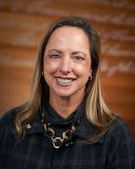

Elizabeth Kubala is a Teaching Professor and the Executive Director of the Betty and Michael D. Wohl Veterans Legal Clinic (VLC). At Syracuse University, Kubala oversees VLC operations, supervises student attorneys in representation of veterans, teaches the Veterans Legal Clinic Seminar, and supports veteran community relations.
Kubala joined the College of Law from the Syracuse University Institute for Veterans and Military Families, where she served since 2015 as a Senior Director, managing the delivery of programs and services across the nation for service members, veterans and their families.
She retired from the U.S. Army at the rank of Lieutenant Colonel following 22 years of active service. She served in numerous staff and leadership positions throughout her military service, with her last assignment as a Military Judge while stationed at Fort Drum, NY.
Kubala received her commission as a military intelligence officer from West Point. Following graduation, she served as a platoon leader, company executive officer, and battalion intelligence officer at Fort Hood, TX. Selected for the Army’s Funded Legal Education Program, she attended law school and then transitioned into the U.S. Army Judge Advocate General’s (JAG) Corps.
As an Army lawyer, Kubala initially served as an administrative law attorney, ethics counselor, and prosecutor at Fort Hood. Later, while assigned to the Pentagon, she served as a legal advisor to the Army Inspector General, and then as a legal advisor to the Army Staff in the Office of the Judge Advocate General. From the Pentagon, she performed public affairs duties as the media spokesperson for the Military Commissions trials at Guantanamo Bay, Cuba. During an overseas tour in Germany, she served as the Executive Officer for the U.S. Army Europe’s legal office. For her final assignment in the Army, she presided over military courts-martial cases as a Military Judge at Fort Drum.
Kubala earned her L.L.M. in 2005 from the U.S. Army’s Judge Advocate General’s Legal Center and School; J.D. in 2000 from the University of Missouri, Kansas City; and B.S. in 1993 from the United States Military Academy at West Point.

Rachel Vanlandingham

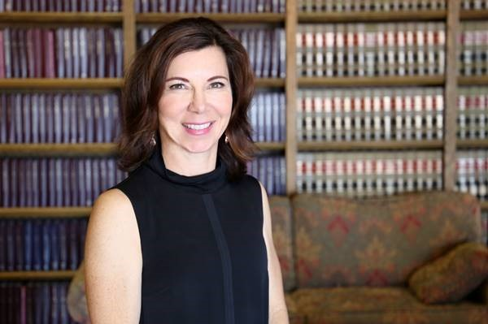

Professor Rachel E. VanLandingham is the Irwin R. Buchalter Professor of Law at Southwestern Law School, Los Angeles, California where she teaches criminal law, criminal procedure, the law of armed conflict, and national security law. Prior to teaching, Prof. VanLandingham was on active duty in the U.S. Air Force for 20 years, including more than a decade as a Judge Advocate (military lawyer). Her tours focused on both criminal law (as a trial and appellate defense counsel) as well as the law of armed conflict. As the legal advisor for international law at Headquarters, U.S. Central Command, Prof. VanLandingham advised on operational and international legal issues related to the armed conflicts in Afghanistan and Iraq. She was also the command's first Chief Liaison to the International Committee of The Red Cross. Prof. VanLandingham is the co-editor of the 2015 Oxford University Press book, Military Operations: Law, Policy and Practice, which details the operationalization of law across the spectrum of U.S. military operations, and is a co-editor of a leading military criminal law casebook, Military Justice: Cases And Materials, 3rd ed. She is also the author of numerous law review articles regarding military criminal law, the law of armed conflict, and the intersection of both with the freedom of expression. Prof. VanLandingham was the 2015 winner of the Benjamin Ferencz Essay Competition for her article, Criminally Disproportionate Warfare: Aggression as a Contextual War Crime. She is currently the President of the National Institute of Military Justice, sits on the editorial board of the Journal of National Security Law and Policy, is the past chair of the national security law section of the Association of American Law Schools, and is a frequent media commentator regarding military legal issues.

Robert B. Murrett

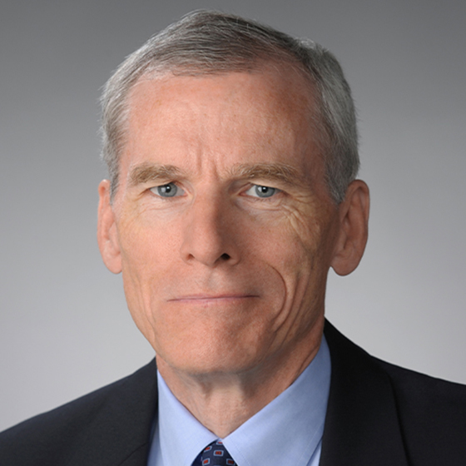

Robert B. Murrett is a faculty member in the department of public administration and international affairs and serves as the deputy director of the Syracuse University Institute for Security Policy and Law (SPL). He holds a courtesy faculty appointment with the Forensic and National Security Sciences Institute and is on the advisory board of the Institute for Veterans and Military Families, both at the University.
In 2016, Murrett was the recipient of the Birkhead-Burkhead Teaching Excellence Award and Professorship at the Maxwell School, and currently serves as the principal investigator for the Intelligence Community Center of Academic Excellence (IC CAE) Program. In addition, he is a staff member at the RAND Corporation and the Institute for Defense Analyses, and chairs the MITRE Intelligence Advisory Board.

Brian Taylor
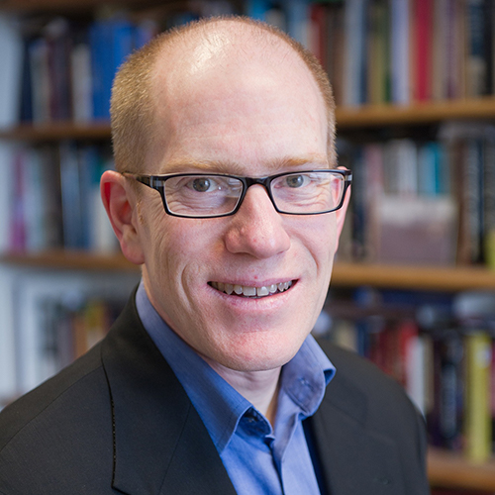
Brian Taylor is a Professor in the Maxwell School Political Science Department at Syracuse University. His primary research interests are in the realm of Russian politics. Much of his research has focused on the development of the Russian state, with particular attention to state coercive organizations, such as the military and the police. He as also written on Russian elite politics, including the nature of Putinism as a mentality and political system. Additional interests include comparative state-building and civil-military relations.

Laurie Hobart
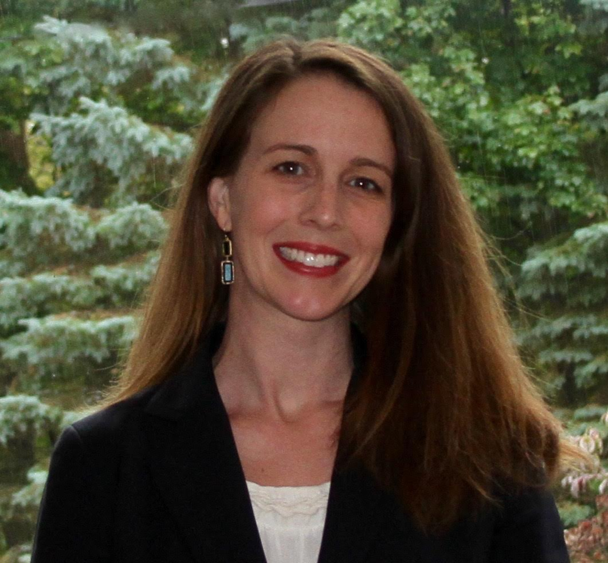
Laurie Hobart teaches national security law at the College of Law, where she joined the faculty in 2017. She has worked as an Honors Attorney and Assistant General Counsel within the Intelligence Community, serving in litigation, administrative law, and contract law divisions, and receiving a Harvard Heyman Fellowship for federal service. She has also worked as an associate at King & Spalding LLP, and as a law clerk to the Hon. Charles F. Lettow of the U.S. Court of Federal Claims. She received a B.A., summa cum laude, from Cornell University’s College of Arts & Sciences, a J.D. from Harvard Law School, and an M.F.A. in fiction writing from Syracuse University.
At Syracuse, Hobart has taught national security law; counterterrorism law; a research seminar on privacy, surveillance, and new technology; legal research and writing courses; and undergraduate English and writing courses.

Adam M. Smith
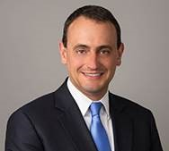

Adam M. Smith is a partner at Gibson, Dunn and Crutcher, LLP in Washington, D.C. where he helps lead the firm’s international trade and sanctions practice. Adam advises companies on mission critical matters including providing compliance guidance, representing them before U.S. and foreign governments, and defending them against enforcement actions brought by regulators around the world.
Adam’s expertise is sought out by governments, international and domestic legal tribunals, academia, and other law firms, and his analysis can be frequently seen in print and broadcast media (including recently in The Economist, Foreign Affairs, the Wall Street Journal, the N.Y. Times, and the Washington Post, and on BBC, CNN, MSNBC, PBS, CNBC, and NPR). In 2019, Adam was the lead author of a commissioned volume for Bloomberg BNA, U.S., EU, and UN Sanctions: Navigating the Divide for International Business, the first-ever desktop treatise on the topic.
Prior to joining Gibson Dunn, Adam served in the Obama Administration as the Senior Advisor to the Director of the U.S. Treasury Department’s Office of Foreign Assets Control (OFAC) – the U.S. Government’s economic sanctions agency – and as the Director of Multilateral Affairs on the National Security Council.
Adam is the author of three legal texts and dozens of articles and book chapters, has testified before the U.S. Congress, and is a frequent presenter at industry, governmental, and academic conferences globally. Earlier in his career, Adam was a law clerk for the Honorable James Baker at the United States Court of the Appeals for the Armed Forces, served as a political economist at the United Nations, and also held posts at the World Bank and the OECD. Adam earned his law degree from Harvard, his master’s degree from Oxford, and his bachelor’s degree from Brown.

Kristen Patel
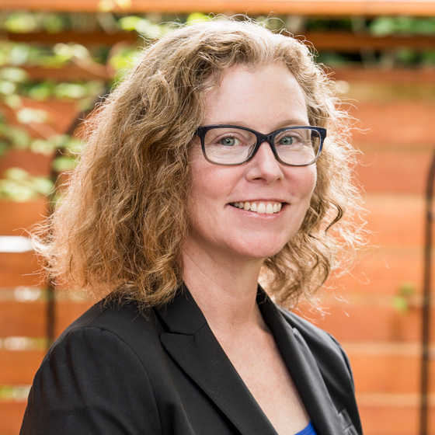
Kristen (Kris) Patel, a distinguished alumna of the Maxwell School (’90 B.A. in Econ, PSt) with more than 25 years of experience leading intelligence and analytics programs in the public and private sectors, is the Donald P. and Margaret Curry Gregg Professor of Practice in Korean and East Asian Affairs. In her role, Patel serves as a faculty member in the Policy Studies Program and teaches undergraduate courses in policy studies and graduate courses in public administration and international affairs. In addition, Patel is a research associate in Maxwell’s Program for the Advancement of Research on Conflict and Collaboration (PARCC) and contributes to Syracuse University’s Intelligence Community Center of Academic Excellence.
Patel has extensive first-hand experience building and leading intelligence and research analytics programs within a national and international context. Over her 25 year career, Patel has developed and managed numerous large teams of high performing intelligence analysts focused on proactive intelligence and network analysis, particularly qualitative and quantitative analysis of large, transnational networks to identify a wide spectrum of financial crime and national security risks.
Patel most recently served as regional head of research & analytics in Asia-Pacific for HSBC, one of the world’s largest banks, where her responsibilities included building and managing a regional financial crime intelligence capability based in Hong Kong. Prior to joining HSBC in 2017, Patel served as the deputy director of intelligence at the Financial Crimes Enforcement Network (FinCEN) in the U.S. Department of Treasury. In addition to directing strategic support for a wide range of US Government customers and foreign partners on high priority issues, she co-led the Egmont Group of Financial Intelligence Units multilateral analytic effort against foreign terrorist fighters, including co-authoring analytic products with several international partners.
Patel has also served in a variety of senior management roles in Asia and Washington D.C., at the DNI Open Source Center (OSC) and Central Intelligence Agency. In addition to serving as OSC Bureau Chief in Seoul, South Korea, and managing day-to-day operations in the CIA/Sherman Kent School’s largest analytic program, she led U.S. government interagency initiatives related to counter-terrorism and proliferation issues and provided daily intelligence briefings for senior NSC staff and White House advisors.
William Casey Biggerstaff
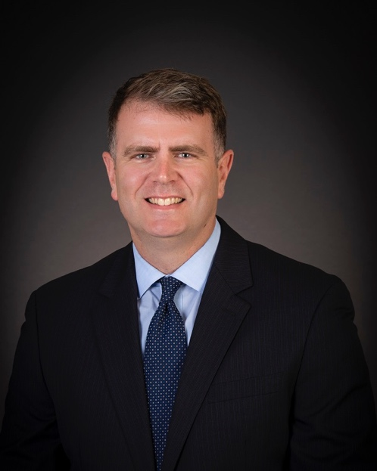
U.S. Army Maj. Casey Biggerstaff is a military professor at the U.S. Naval War College Stockton Center for International Law. The Stockton Center serves as the world’s premier research institute for the study of international law and military operations throughout the domains of land, sea, aerospace and cyberspace. Stockton Center faculty teach in the core curriculum and electives at NWC as well as in advanced international law courses around the world.

Also Featured on Panels:

Renn Gade
Deputy General Counsel, Department of Defense

Major Jason Harrup
Chief of National Security Law, 10th Mountain Division, U.S. Army

